CATATAN Tgl 28 November 2024:

Hal pertama V’elconsulting nya kecil banget:

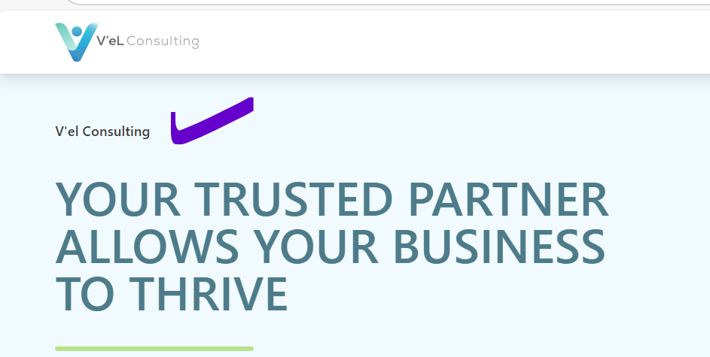

Our Value:



Values for our clients, employees and community, driven firm with professional ethics, innovation and integrity

Contact us: untuk email dengan alamat sbb:

Valery Budy Rakhayu – Budy nya salah atau di buang saja.

Alamat email nya:

[valery.rakhayu@velconsulting.co.id](mailto:valery.rakhayu@velconsulting.co.id)

Nomor Contact: +62 8159901717

[Lucia.adrianti@velconsulting.co.id](mailto:Lucia.adrianti@velconsulting.co.id)

Nomor Contact: +62 8129512538

Nomor hp di buat atas bawah, dan bisa di klik nyambung ke wa.

Alamat : Pakuwon Tower, 9th Floor, Kasablanka Raya Kav 88, Jakarta Selatan, 12870

Susunan partner bikin foto dan bisa di klik masing masing partner.

Untuk team lain EEn, Icha, Boinser, Naomi, Seno dll di masukkan dalam foto collage saja. Di info bahwa: *Our team have experiences and education background in accounting, tax, capital market and finance*

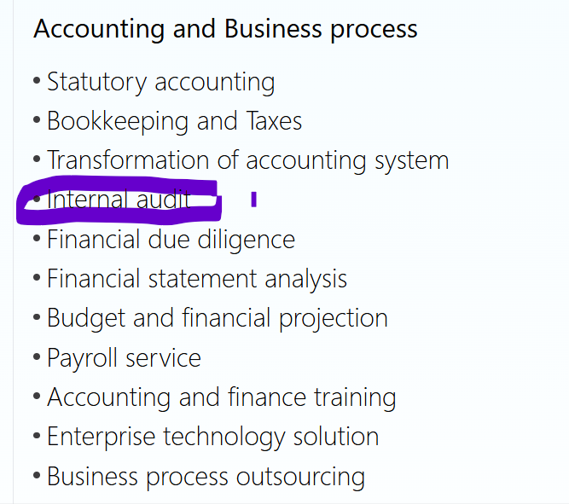

**Vision: Indonesia nya huruf besar**

Photo di sini:

<https://drive.google.com/drive/folders/1P-qj-sj86RXpsuT3T_jDD3rvPOYLtVNf?usp=sharing>

<https://drive.google.com/drive/folders/1uJ-L9GIfSAnG_3lij_MuYvXsTppglX5z?usp=sharing>

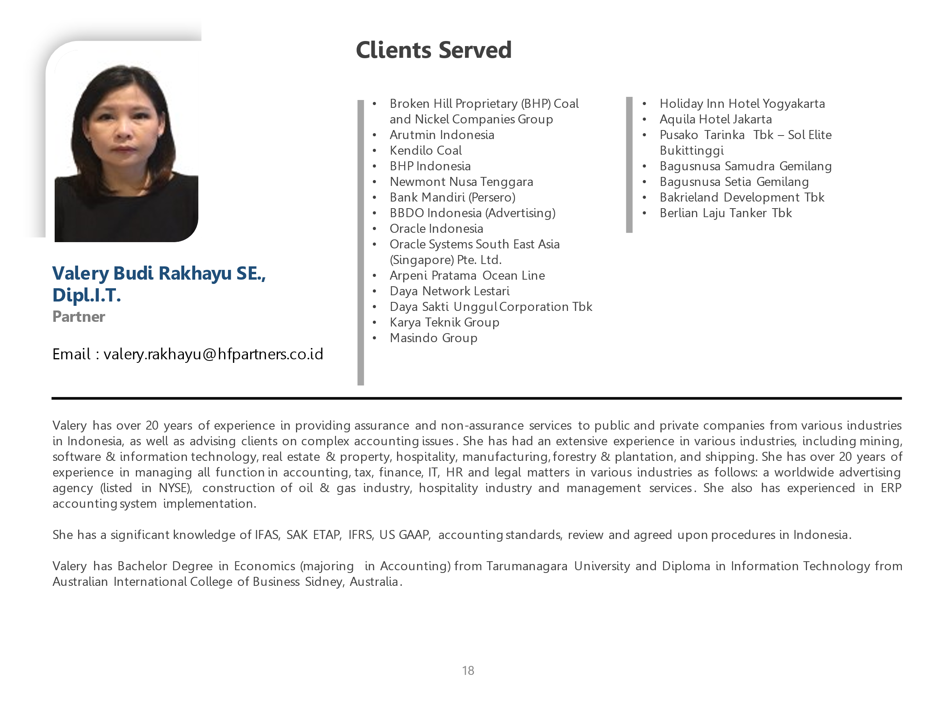

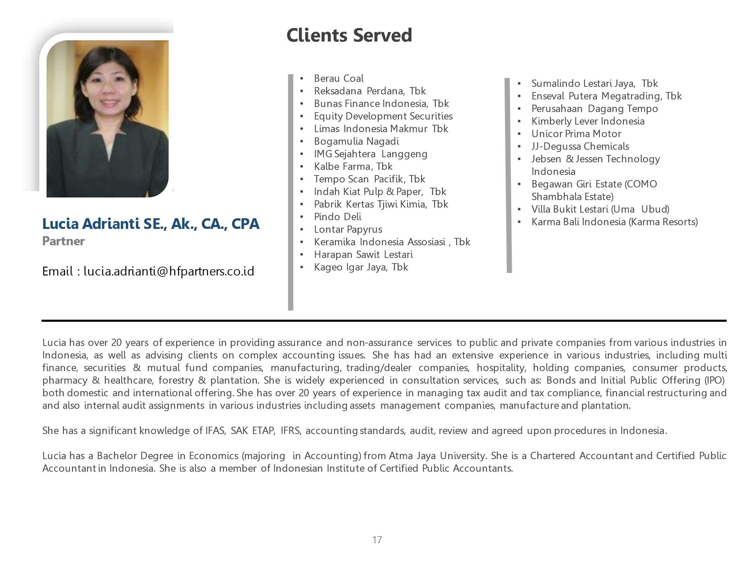

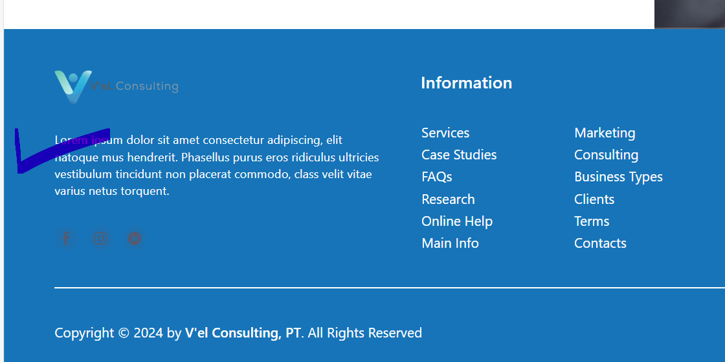

Yang centang di ganti kata kata:

*Our services grants your company the freedom to focus on your core business activities and growth, while we take care of the time-consuming details.*

Yang Information – tolong di sesuaikan

Our Client:

 Continental Tyre Indonesia

*  Lotte Data Communication Indonesia
*  Obayashi Corporation
*  Aruna Indonesia Group  Esco Utama Wellesta CPI

Super Steel Karawang

 Eco Regions

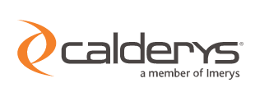Indoporlen

Worckhardt Pharma Indo

 Nilpeter

 Nation Insight



 Asia Biogas

 Norwegian Agency for development Cooperation

China Railway International

 SCI ecommerce

 Thyssenkrupp Industrial Solution

 Mega Masindo Internasional

 Karya Teknik Agri Group